HMS Software Design Document



Session: 2021 – 2025

Submitted by:
Saleem Malik(2021-CS-32)
Mustafa Riaz(2021-CS-39)
Abdur Rehman(2021-CS-44)

Supervised by:
Sir: Atif Warraich

Department of Computer Science
University of Engineering and Technology Lahore Pakistan

TABLE OF CONTENT
Preface 2
Table of Contents
TABLE OF CONTENT 2
Table of Contents 3
1.1. Purpose 3
1.2. Scope 3
1.3. Definitions, Acronyms & Abbreviations 4
3. System Components 6
3.1. Decomposition Description 6
3.1.1. Module Decomposition 6
3.1.2. Data dependencies 15
A user can book several rooms. A room can be reserved by one user. 16
3.2. 3.3 Interface Description 17
3.2.1. Module Interfaces 17
3.3. Module Detailed Design 17
3.3.1. Login Module 17
3.3.2. Register Module 17
3.4. Data Detailed Design 18
3.4.1. Users Table………………………………………………………………………………………………………………..19
3.4.2. Customers Table………………………………………………………………………………………………………..20
3.4.3. Rooms Table……………………………………………………………………………………………………………..20
3.4.4. RoomBookings Table…………………………………………………………………………………………………21
3.4.5. Meals Table……………………………………………………………………………………………………………….22
3.4.6. MealOrders Table……………………………………………………………………………………………………..22

1. Introduction

1.1. Purpose
The purpose of Software Design Description is to identify what need to coded that is specified in SRS. In this document, brief information of Hotel Management System will be given.

1.2. Scope
In this document, the detailed description of Hotel Management System will be given. Our hotel management system project will have a web interface.
In the web interface, there are 3 types of user and which are;
-Administration
-Staff
-Authorized user
Each user type will have a different authorization to access to the system.

Definitions, Acronyms & Abbreviations
DB | Database
FP | Function Points
GUI | Graphic User Interface
HW | Hardware
IDE | Integrated Development Environment
IE | Internet Explorer
IEEE | Institute of Electrical and Electronics Engineers
I/O | Input / Output
IP | Initial Plan
KU | Knowledge Unit
PY | Python
LOC | Line Of Code
MS | Microsoft
PS | Problem Statement
RAM: | Random Access Memory
SDD | Software Design Description
SPMP | Software Project Management Plan
SQL | Structured Query Language
SRS | Software Requirements Specification
SW | Software

- System Overview

Hotel management system is a desktop application based project, which helps to hotel employees interacting to clients and each other. To do this, hotel management system has messaging, sending e-mail module

3. System Components

Decomposition Description

Module Decomposition
The way followed while making module decomposition is to divide the system into modules so that the operations are done under each module will be higly related with each other, but they are not so much related with other operations in other modules. Taking this into consideration, hotel management system project’s main services are as follows;
3.1.1.1 User Authetication Module
Identification: User Authentication Module
Type: Application
Purpose: This Module provide user to register and authenticate user.
Function: User enables to register to system and log in. Also this module provide changing password and help user if they forgot their password.
Subordinates:
- Sing in
- Log in
- Changed Password
- Forgotten Password
3.1.1.1.1. Sign in
Identification: Sign in
Type: Process
Purpose: Provides user to get their authorization level which is recorded in corresponding cell of the user table.
Function: A user enters their required information (e-mail, password) to the web form. If those information match with a row of the user table, user gets their authorization level.
Subordinates:
3.1.1.1.2. Sign Up
Identification: Sign up
Type: Process
Purpose: Provides a registration process to user, if user information is not
recorded to the user table.
Funtion: A visitor fills the registration form and click on the Complete Registration button. If every information given is correct, user's information is recorded to user table and user get the “customer”status by default. For other employee is defined by the administrator in their panel manually.
3.1.1.1.4. Change Password
Identification: Change Password
Type: Process
Purpose: To make user able to change their passwords.
Funtion: User enters their old password and new password. New password replaces with the old password if it is correct.
Subordinates:
3.1.1.1.5. Forgotten Password
Identification: Forgotten Password
Type: Process
Purpose: By this module, user can get their fogotten password.
Funtion: User sends a request to the system that denotes they have forgotten their password. System sends them an e-mail including their password.
Subordinates:
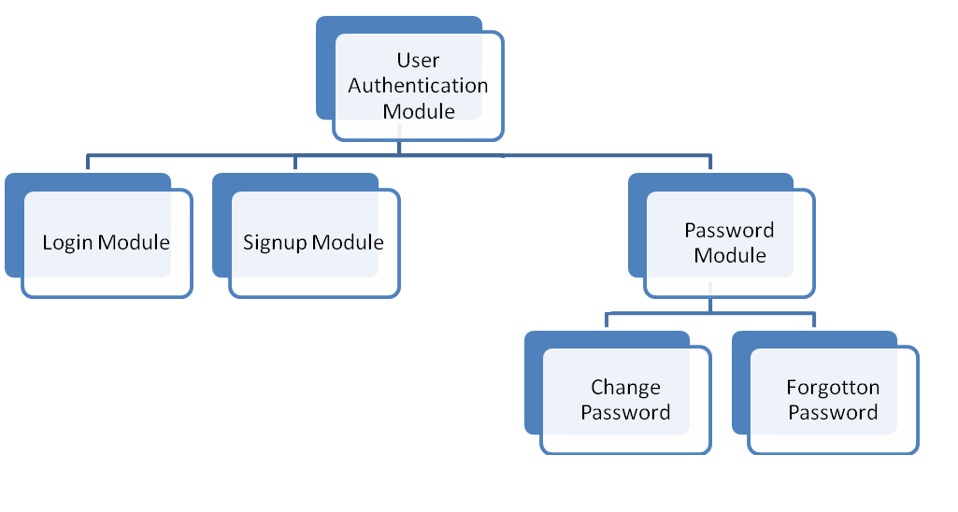

3.1.1.3 Searching Module
Identification: Searching Module
Type: Application
Purpose: It allows user to searching infomration, data in the system.
Function:
Subordinates:
Searching Module(Administrator)
- Search Room
- Search Employee
- Search Customer
3.1.1.3.1 Search Room (Administrator)
Identification: Search Room
Type: Process
Purpose: Provides a sophisticated room searching to administrators.
Funtion: Administrator enters the capacity and price intervals to the module.
All suitable rooms are listed.
Subordinates:
3.1.1.3.2 Search Employee
Identification: Search Employee
Type: Process
Purpose: Provides administrator to search employee by type, name, etc.
Funtion: Administrator specifies how the search will be done, all suitable employee information are listed.
Subordinates:
3.1.1.3.3 Search Customer
Identification: Search Customer
Type: Process
Purpose: Provides administrator to search customer by name and SSN.
Funtion: Administrator specifies how the search data, all suitable customer information are listed.
Subordinates:
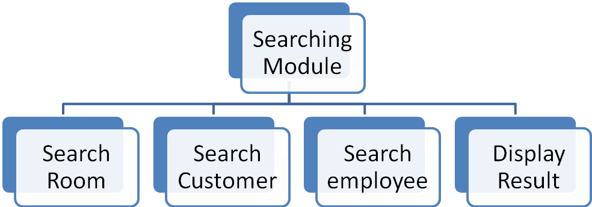
3.1.1.5 Online Reservation Module
Identification: Online Reservation Module
Type: Application
Purpose: This module allows to customer
Function:
Subordinates:
- Reserve Room
- Modify Reservation
-Cancel Reservation
3.1.1.5.1 Reserve Room
Identification: Reserve Room
Type: Process
Purpose: Provides customer to reserve a room.
Funtion: Customer picks a room. Specifies entering and leaving dates and how the room price will be paid. Clicks on reserve button.
Subordinates:
3.1.1.5.2 Modify Reservation
Identification: Modify Reservation
Type: Process
Purpose: Provides customer to change their reservation information.
Funtion: Customer clicks on modify reservation button. They can change any information about the room and cancel the reservation.
Subordinates:
3.1.1.5.2.1 Cancel Reservation
Identification: Cancel Reservation
Type: Process
Purpose: Provides customer to cancel the reservation. Any related data in the reservation table will be erased.
Funtion: Customer clicks on cancel reservation button. Reservation is canceled.
Subordinates:
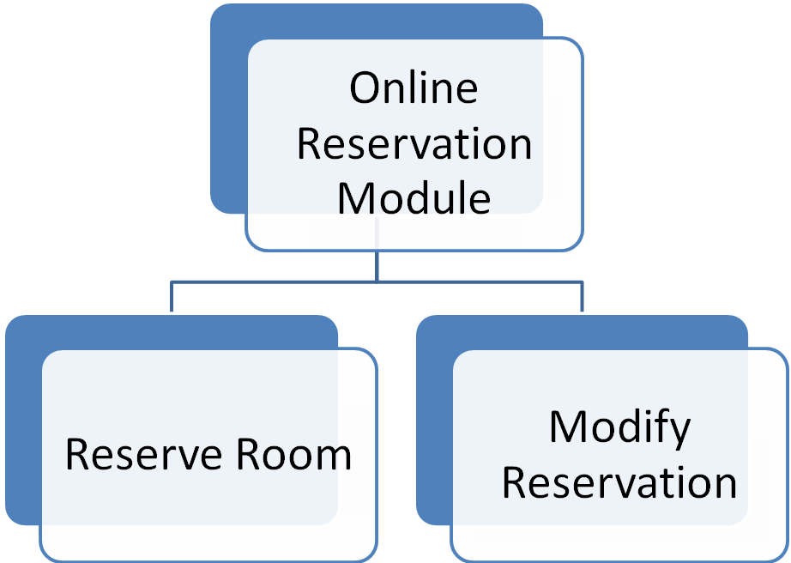

3.1.1.6 Manage Room Module
Identification: Manage Room Module
Type: Application
Purpose: Adminstator enable to manage room.
Function: This module provides add, delete or change room information like room is vacated or occupied.
- Add Room
- Delete Room
3.1.1.6.1 Add Room
Identification: Add Room
Type: Process
Purpose: Provides administrator to add a new room.
Funtion: Administrator clicks on “Add new Room” button, fills the form according to room specifications, clicks on save button.
Subordinates:
3.1.1.6.2 Delete Room
Identification: Delete Room
Type: Process
Purpose: Provides administrator to delete a room.
Funtion: Administrator clicks on “Delete Room” button, clicks on save button. Because room information does not erased from the database, this process is reversible.
Subordinates:
3.1.1.6.1 Modify Room Information
Identification: Modify Room Information
Type: Process
Purpose: Provides administrator to modify a room's information.
Funtion: Administrator clicks on “Modify Room Information” button, all the information can be changed.
Subordinates:
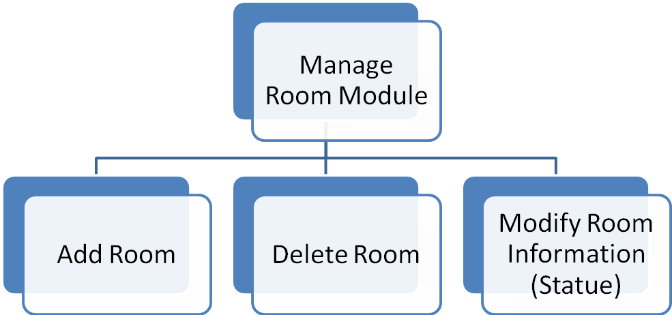
3.1.1.8 Employee Management Module
Identification: Employee Management Module
Type: Application
Purpose: Employee management module provides recording all user information except from customer.
Function: Adding, deleting and modifying employee information.
Subordinates:
- Delete Employee
- Modify Employee Information
- List Employees
3.1.1.8.2 Delete Employee
Identification: Delete Employee
Type: Process
Purpose: Provides administrator to delete an employee.
Funtion: When an employee is fired or quit, administrator clicks on “Delete employee” button and employee is deleted from user table.
Subordinates:
3.1.1.8.3 Modify Employee Information
Identification: Modify Employee Information
Type: Process
Purpose: Provides administrator to modify an employee's information.
Funtion: When it is required, administrator clicks on “Modify” button and makes the necessary changes.
Subordinates:
3.1.1.8.4 List Employees
Identification: List Employees
Type: Process
Purpose: Provides administrator to list all the employees according to
given interval.
Funtion: Administrator clicks on “List” button and specifies the listing property. All the suitable employee information are listed.

Subordinates:
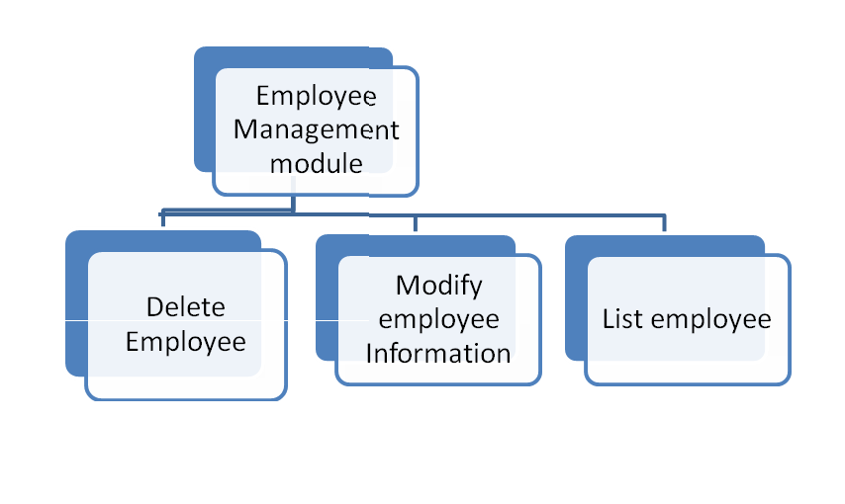
3.1.1.9 Contact to Supplier Module
Identification: Contact to Supplier Module
Type : Application
Purpose: Administrator can control Supplier relation in side of order.
Function: This module provides contact to supplier, sending email and order.
Subordinates:
- Search Supplier
- Send E-Mail
3.1.1.9.1 Search Supplier
Identification: Search Supplier
Type: Process
Purpose: Provides administrator to search suppliers.
Funtion: Administrator clicks on “Search” button and specifies the wanted supplier properties. All the suitable suppliers are listed.
Subordinates:
3.1.1.9.2 Send E-Mail
Identification: Send E-Mail
Type: Process
Purpose: Provides administrator to send an e-mail to supplier.
Funtion: Administrator clicks on e-mail link in the supplier information, clicks on “Send” button.
Subordinates:
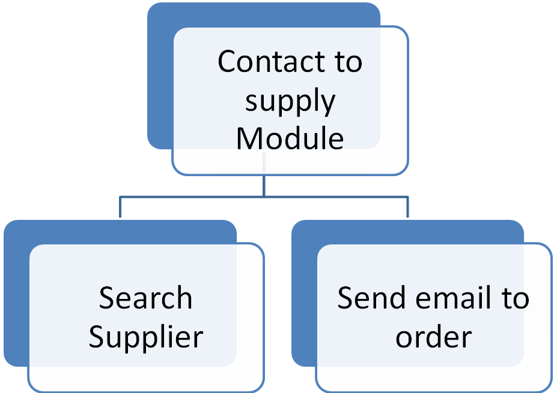
3.1.1.10. Announcements Module
Identification: Announcement Module
Type: Application
Purpose: This module provides giving information about events.
Function: Administator enable to add, delete or change announcement.
Subordinates:
- Add Announcement
- Delete Announcement
- Modify Announcement
3.1.1.10.1 Add Announcement
Identification: Add Announcement
Type: Process
Purpose: Provides administrator to add a new announcement.
Funtion: Administrator clicks on “Add new Announcement” button,enters the announcement information and clicks on “Done” button.
Subordinates:
3.1.1.10.2 Delete Announcement
Identification: Delete Announcement
Type: Process
Purpose: Provides administrator to delete an announcement.
Funtion: Administrator clicks on “Delete” button, and deletes the announcement.
Subordinates:
3.1.1.10.2 Modify Announcement
Identification: Modify Announcement
Type: Process
Purpose: Provides administrator to modify an announcement.
Funtion: Administrator clicks on “Modify” button, makes the necessary changes, clicks on “Done” button.
Subordinates:

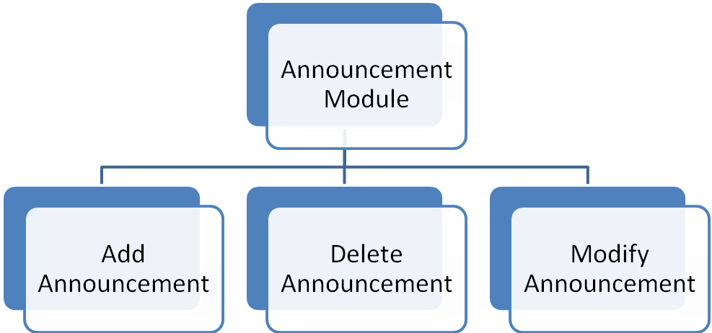

Data dependencies
In this part of SDD, relations between entities will be mentioned.
userregistrationInfo – userGeneralInfo
userRegistrationInfo | 1 | 1 | userGeneralInfo
1:1 relation. A user can have one general information. A general information can belong to one user.

userregistrationInfo – messages
userRegistrationInfo | 2 | M | Messages

2:M relation. A user may have many messages. A particular message belongs to two users which are sender and receiver.
userregistrationInfo – announcement
userRegistrationInfo | 1 | N | Announcement

1:N relation. One user(administor) can give several announcements. An announcement may belong to one user(administrator).
userregistrationInfo - room

userRegistrationInfo | 1 | N | Room

A user can book several rooms. A room can be reserved by one user.

3.3 Interface Description

Module Interfaces
In this part of SDD, communication between modules is explained in detail.
Database Module | < - > | ViewInformation viewReservedRoom viewMessages viewMails | < - > | Profile Module
Database Module | < - > | login registration passwordTransections | < - > | Authentication Module
Database Module | < - > | setHeader setImage setContent announcementHistory | < - > | Announcement Module

Module Detailed Design

Login Module
Method Name: Login
Description: allows users to enter the system
Share Type: public
Return Type: Boolean
Parameters: username, password, imageVerification

Register Module

Method Name: registration
Description: registers a new user to the system
Share Type: public
Return Type: boolean
    - Reservation Module:
Allows the front desk to manage room reservations.
Tracks guest information, check-in, and check-out dates.
Provides room availability status.
Parameters: firstName, lastName, password, email, birthDate, gender, country, city, distinct.
    - Check-In/Check-Out Module:
Manages the check-in and check-out processes.
Updates room status upon check-in and check-out.
    - Room Management Module:
Handles room inventory, availability, and maintenance.
Allows for room categorization (e.g., standard, deluxe).
    - Billing and Invoicing Module:
Manages guest billing, including room charges and additional services.
Generates and sends invoices to guests.
    - Guest Management Module:
Maintains guest profiles and history.
Manages guest preferences and special requests.
    - Reporting Module:
Generates various reports for management analysis.
Includes occupancy reports, revenue reports, etc.
    - Employee Management Module:
Manages employee information, roles, and schedules.
Handles payroll and attendance.

Data Detailed Design
    - Table Name: Users
This table holds user’s registration information.
Column Name | Data Type | Description | Example
userId (PK) | INT | primary key, auto increment, not null | 1
firstName | VARCHAR(15) | holds first name of user | Murat
lastName | VARCHAR(15) | holds last name of user | Çatal
Password | VARCHAR(15) | holds password of user | $123_321$
Email | VARCHAR(45) | holds email of user | murat@gmail.com
templateId | INT | holds the template id of user. This column is PK for template table. | 23333
Table 1: Users

    - Table Name: Customers
This table holds customers information.
Column Name | Data Type | Description | Example
customerID (PK) | INT | primary key, auto increment, not null | 1
firstName | VARCHAR(15) | holds first name of user | Murat
lastName | VARCHAR(15) | holds last name of user | Çatal
Phone Number | VARCHAR(15) | holds phone number of user | +923096435752
Feedback | VARCHAR(45) | holds email of user | murat@gmail.com
Table 2: Customers

    - Table Name: Room
This table holds room information.
Column Name | Data Type | Description | Example
roomID (PK) | INT | primary key, auto increment, not null | 1
roomNumber | VARCHAR(15) | holds room number | 22
occupant | VARCHAR(15) | holds name of user | Mustafa
isAssured | VARCHAR(15) | true of false | True
Table 3: Rooms

    - Table Name: RoomBookings
This table holds room booking information information.
Column Name | Data Type | Description | Example
bookingID (PK) | INT | primary key, auto increment, not null | 1
customerId | VARCHAR(15) | holds room number | 22
roomNumber | VARCHAR(15) | holds name of user | 100
CheckInDate | BOOL | true of false | 21/9/2002
CheckOutDate | VARCHAR(15) | Holds check out date | 21/10/2002
IsAssured | BOOL | Store confirm assurance | true
ConfirmationNumber | INT | Stores confirmation number | 15
Table 4: RoomBooking

    - Table Name: Meals
This table meals information.
Column Name | Data Type | Description | Example
MealID (PK) | INT | primary key, auto increment, not null | 1
Description | VARCHAR(15) | holds meal information | This meal is.....
Price | VARCHAR(15) | holds meal price | 100
Table 5: Meals

    - Table Name: MealOrder
This table holds meal order information.
Column Name | Data Type | Description | Example
orderID (PK) | INT | primary key, auto increment, not null | 1
CustomerID | INT | holds room number | 22
MealID | INT | holds name of user | Mustafa
PaymentType | VARCHAR(15) | true of false | True
Table 6: MealOrder

